VIRTUAL NETWORK CARD FOR ASTER

Run with Admin right INTEL_VLAN_CREATOR.exe (ver 1.5)
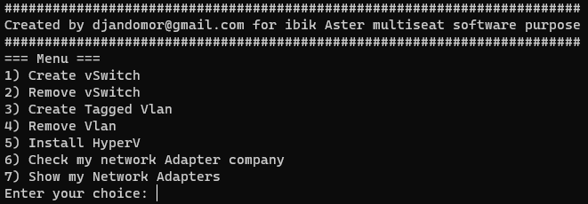
Select 6 and press Enter
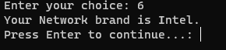
If you got Intel you can continue using INTEL_VLAN_CREATOR
If brand of your network adapter is from Realtek download Realtek Ethernet Diagnostic Ultility from realtek.com
https://www.realtek.com/en/component/zoo/category/network-interface-controllers-10-100-1000m-gigabit-ethernet-pci-express-software

Choice option 7

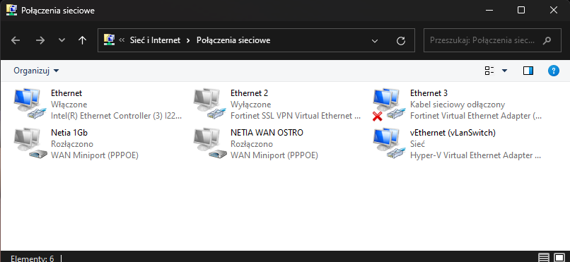

You will see all your Network adapters
Select 5 to install HyperV
Then back to 7 and
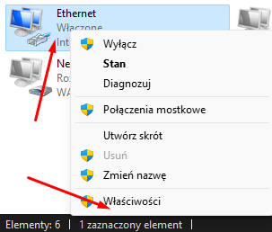
Then follow the pictures to ON the Vlan on Intel NIC
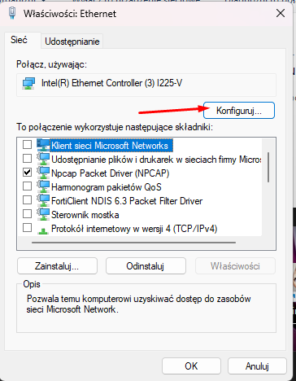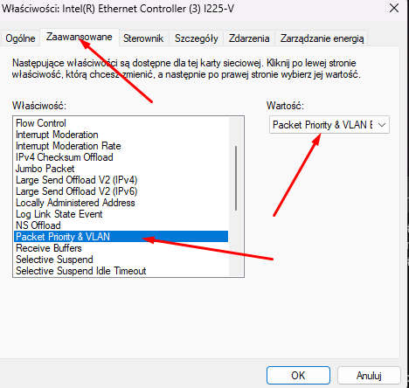

After that restart your PC
And you can start making VLANS :
This will create Your vSwitch
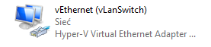
THIS switch is now your "MAIN" Network card and its got IP gate mask etc.
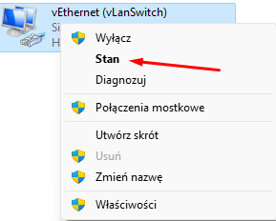
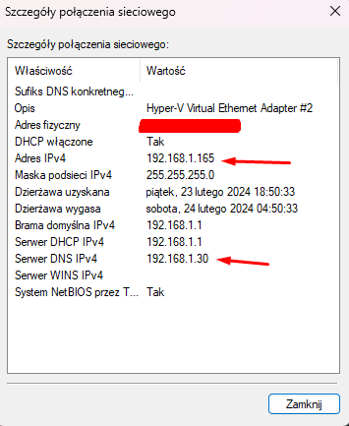
#192.168.1.0/24 its my Network
#Dont get confused about Server DNS IPv4 192.168.1.30 => its local DNS server PiHole to block Ads. - You can write none or 8.8.8.8 or 1.1.1.1
# Then start creating your VLAN

Enter name of your new vEthernet for example VLAN20
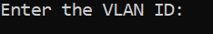
Enter your Tagged vlan from switch in this example 20 and press enter
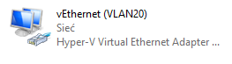
# If you Vlan got DHCP server. Remember to write your ip etc manualy othervise its will be not visible in Aster
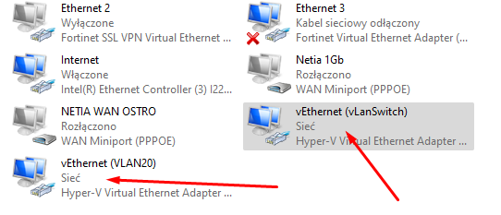
You can create as many vEthernet with tagged vlan as you want
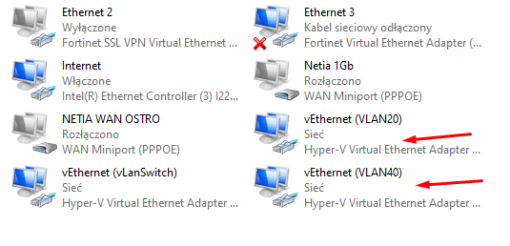
Set in Aster new vethernet Card to each workstation

In next version of INTEL_VLAN_CREATOR
Should be added untaged vlans 1 extra vNetwork Cards

Download INTEL_VLAN_CREATORv1.5.exe from

(MAKE A HYPERLINK Masha) DOWNLOAD
https://ibik.cloud:5001/d/s/xfOiJaO6zXbMiwLQE6oZzTQg7bx6zz5l/fOApPJ3J9-JuioRiLc3E_B7Oa1E7lEIH-qL6AHqygNQs

